**SPRINT:1**

|  |  |
| --- | --- |
| DATE | 11 November 2022 |
| TEAM ID | PNT2022TMID34135 |
| PROJECT NAME | IoT based smart crop protection system for agriculture |
| MAXIMUM MARKS | 20 Marks |

**CREATE AN IBM ACCOUNT:**

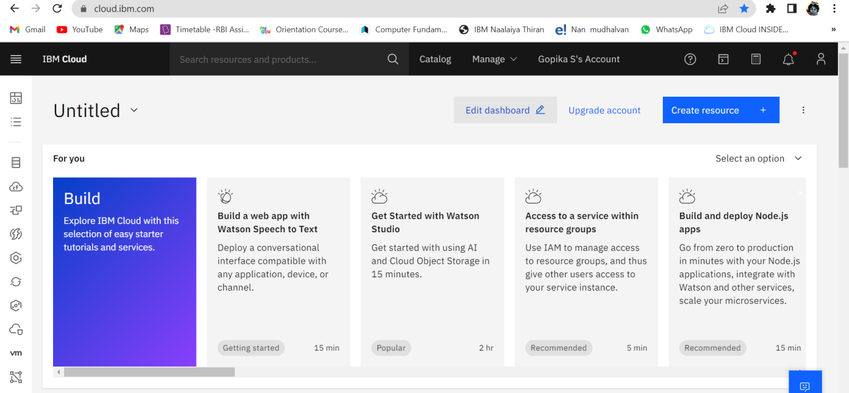

# Configure the IBM Cloud services which are being used in completing this project:

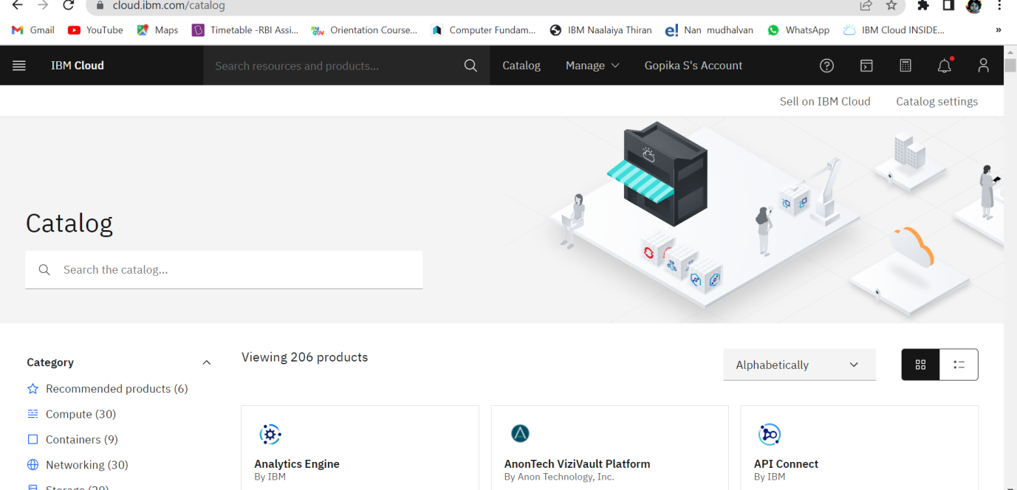

**JIRA sprint 1 issue link:**

[**https://pnt2022tmid34135.atlassian.net/browse/IBSCPSFA-15**](https://pnt2022tmid34135.atlassian.net/browse/IBSCPSFA-15)

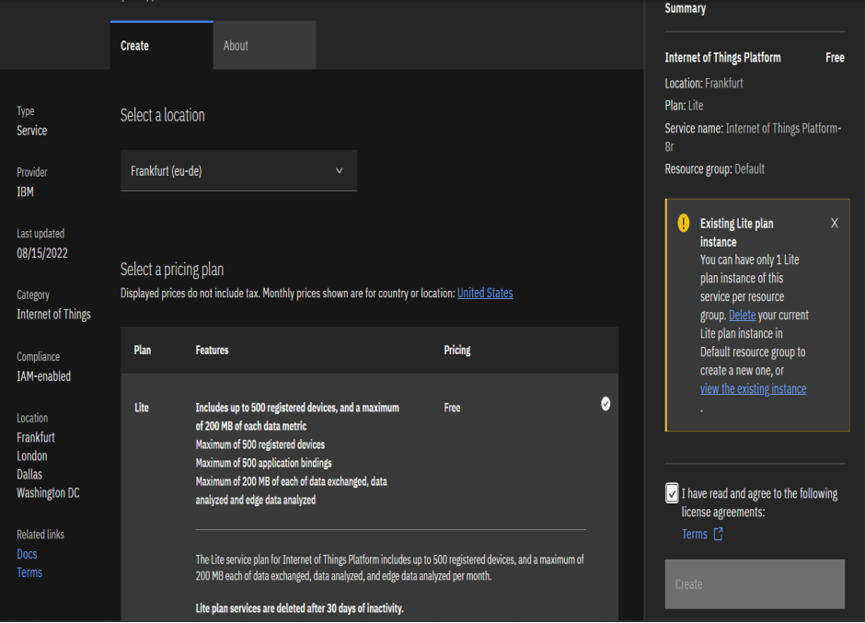

**DEVELOPED AN JIRA SOFTWARE:**

